Stryder News January Edition

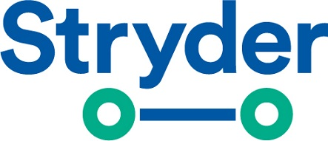
Brain Bootcamp Registrations now open!
"The 2020 Dementia Australia Prevalence Data reveals that there is currently an estimated 459,000 people living with all forms of dementia. Without a major medical breakthrough this figure is projected to increase to 1,076,000 people by 2058".
Raising Dementia Awareness
Brain Bootcamp: Where better brain health begins
Our very own local member Dr Joyce Siette has been funded by NSW Government to create a public health initiative known as Brain Bootcamp. Supported by Macquarie University, this initiative aims to increase seniors' awareness of dementia risk factors and initiate lifestyle changes to maximise brain health.

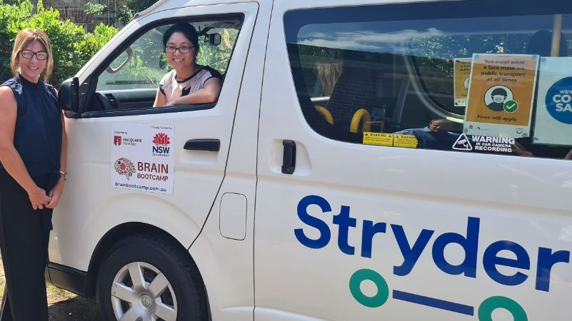

Adults over 65 are invited to fill out an online survey at the Brain Bootcamp website www.brainbootcamp.com.au to create their own personalised brain health profile which will be included inside a gift box and delivered to their door for free. The box will also contain educational resources and easy-to-implement strategies for healthy ageing. They will also receive complementary Brain Bootcamp items that will help kickstart their journey to better brain health.
Registration opens on Monday 18th January 2021. There are only 1000 gift boxes available! For more information, please email info@brainbootcamp.com.au or call (02) 9850 2210

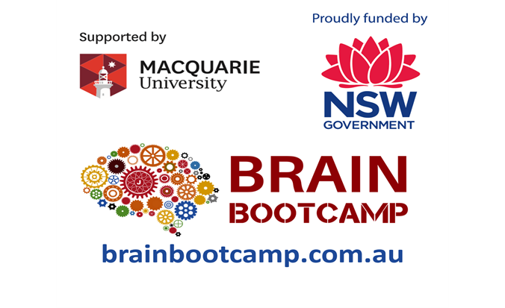

Don't miss out - Book in now!

